

**School of Engineering**

**Major Project**

**On**

**VIRTUAL FUNHUB**

Academic Year: May, 2022-23

|  |  |
| --- | --- |
| Student’s Full Name: | Vedant Rajpurohit  Rinkesh Patel  Manan Patel |
| Enrollment No: | 20SE02ML036  20SE02ML035  20SE02ML034 |
| Branch: | Artificial Intelligence And Machine Learning |

Supervised by

Ms. MEGHA PATEL

P P Savani School of Engineering



CERTIFICATE

This is to certify that Mr.Vedant Rajpurohit, Enrollment No. 20SE02ML036 from the Department of Engineering, has successfully completed the Major Project on the Virtual Funhub during June – December, 2022-23.

_____________________________ _____________________________

Name and Sign of Supervisor Dean, SOE



CERTIFICATE

This is to certify that Mr.Rinkesh Patel, Enrollment No. 20SE02ML035 from the Department of Engineering, has successfully completed the Major Project on the Virtual Funhub during June – December, 2022-23.

_____________________________ _____________________________

Name and Sign of Supervisor Dean, SOE



CERTIFICATE

This is to certify that Mr. Manan Patel, Enrollment No. 20SE02ML034 from the Department of Engineering, has successfully completed the Major Project on the Virtual Funhub during June – December, 2022-23.

_____________________________ _____________________________

Name and Sign of Supervisor Dean, SOE

**ACKNOWLEDGEMENT**

**AKNOWLEDGMENT**

It is indeed with a great pleasure and immense sense of gratitude that we acknowledge the help of these individuals. We are highly indebted to our Dean Dr. Niraj Shah, Dean, School of Engineering, P P Savani University, for the facilities provided to accomplish this minor project

We feel elated in manifesting our sense of gratitude to our project guides Ms.Megha Patel. She has been a constant source of inspiration for us and we are very deeply thankful to her for her support and valuable advice.

We extremely grateful to our Departmental staff members, Lab technicians and Non-teaching staff members for their extreme help throughout our project.

Finally, we express our thanks to all of our friends who helped us in successful completion of this project.

**Vedant Rajpurohit 20SE02ML036**

**Rinkesh Patel 20SE02ML035**

**Manan Patel 20SE02ML034**

**ABSTRACT**

**Virtual Funhub** is in where we can select the game from the main interface and play games easily with restart and going back feature available for the users.

We are here now, using the techniques of computer vision in open cv to build this project. The required language for this project is python due to its more exhaustive libraries and easy to make use of the syntax and but understanding the basics as well as it can be implemented in any open cv supported languages The hand tracking and detection processes are used to achieve the goal of this project. The hand Tracking and Image processing are the main components of the project.

Image Processing is one of the main features of the project which make it look like real and user friendly (while loading games, starting the game and in build game features which are used to have an user friendly environment.

**Key Words**: Open CV, Python, Erosion, Dilation, Color Tracking, Color Detection, Mask

**INDEX**

|  |  |  |
| --- | --- | --- |
| Sr. No | Component | Page. No. |
|  | Chapter 1: Introduction to Project | 8-10 |
|  | Chapter 2: Literature Review | 11-13 |
|  | Chapter 3: Design and Diagrams | 14-15 |
|  | Chapter 4: Implementation Details | 16-24 |
|  | Chapter 5: Conclusion and Future Work | 25-27 |

LIST OF FIGURES

|  |  |  |
| --- | --- | --- |
| Sr. No | Figure Name | Page. No. |
| 1.0 | Features of python | 8 |
| 2.0 | Open-cv | 9 |
| 3.0 | Extraction | 14 |
| 3.1 | Flow chart | 14 |
| 4.0 | Cycle of Gesture Recognition | 15 |
| 5.0 | Welcome Page | 16 |
| 5.1 | First Loading Page | 16 |
| 6.0 | Main Interface | 17 |
| 7.0 | Snake Game | 18 |
| 8.0 | Rock Paper And Scissors | 19 |
| 9.0 | Eat or Not Game | 20 |
| 10.0 | Pong Game | 21 |
| 11.0 | Balloon Pop Game (Pygame) | 22 |
| 12.0 | Virtual Quiz | 23 |
| 13.0 | Loading Page | 24 |

**CHAPTER 1**

**INTRODUCTION TO PROJECT**

This Report looks into **Virtual reality (VR)** offers a unique platform for visual representation. As means of communication, drawings frame the ways in which architects think about space.

**OBJECTIVE**

* To do image processing and load different images for better user view.
* To detect the human finger which can be used to play different games.
* To do the morphological operations.
* To create an interface between user and the system.

**BACK-END TOOL:**

* **PYTHON**

Python is an open-source (free) Prgmg language that is used in web Prgmg, data science, artificial intelligence, and many scientific applications. Learning Python allows the programmer to focus on solving problems, rather than focusing on syntax.

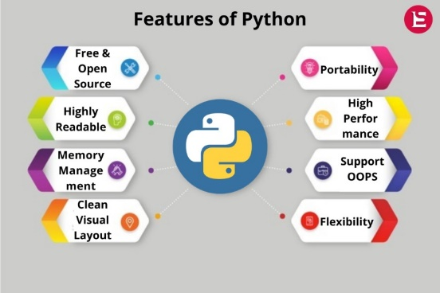

**Figure: - 1.0**

* **OPENCV (Python Library)**

OpenCV (Open-Source Computer Vision Library) is a library which mainly focuses at real-time computer vision. It is free for both academic and commercial use. It has C++, C, Python and Java interfaces and supports Windows, Linux, Mac OS, iOS and Android. OpenCV was designed for computational efficiency and with a strong focus on real-time applications. The library has more than 2500 optimized algorithms, which includes a comprehensive set of both classic and state-of-the-art computer vision and machine learning algorithms. It provides basic data structures for image processing with efficient optimizations.

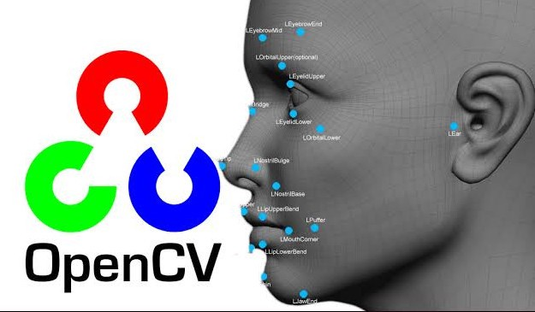

**Figure: - 2.0**

Sketching On Air is possible through our trending technology namely open cv, python. Open cv is mainly known as an open-source computer vision and machine learning software. The library has more than 2400 best algorithms, which includes comprehensive set of classic and state-of-the-art computer vision and machine learning algorithms. Most of these algorithms are used to detect and recognize faces, identify objects, classify human activities in videos track camera movements, track moving objects, extract 3D one’s.

The interaction between people and the machines is mainly completed through the mouse, keyboard, remote control, touch screen, and other direct contact manner, while the communication between people is basically achieved through more natural and intuitive non-contact manner, such as sound and physical movements.

**CHAPTER 2**

**LITERATURE REVIEW**

In the past decades, gestures were usually identified and judged by wearing data gloves to obtain the angles and positions of each joint in the gesture several papers and projects have targeted the issue of hand gesture recognition.

**Francis et al** However, it is difficult to use widely due to the cost and inconvenience of wearing the sensor. In contrast, the non-contact visual inspection methods have the advantage of low cost and comfort for the human body, which are the currently popular gesture recognition methods.

**Chakraborty** proposed the skin color models utilizing image pixel distribution in a given color space, which can significantly improve the detection accuracy in the presence of varying illumination conditions. However, it was difficult to achieve the desired results using the model-based methods because of the light sensitivity during the imaging process. The algorithm-based non-contact visual inspection methods were also used to conduct the gesture recognition, such as the hidden Markov model the particle filter, and Heer features AdaBoost learning algorithm; however, it is difficult to execute real time due to the complicated algorithms. The above results cannot acquire gestures efficiently in real time since only the insufficient 2D image information was used. Therefore, it is inevitable that gesture recognition by 2D image is replaced by 3D with depth information. In general, 3D information can be acquired by binocular cameras, Kinect sensor, Leap Motion and other devices. Those devices can be usually utilized to obtain depth information by spatial relationship of different direction or infrared reflection, which can conveniently acquire non-contact image for recognition and classification instead of wearing the complicated equipment.

To facilitate this process many gestures recognition applications resort to the use of uniquely colored gloves or markers on hands or fingers. But computer vision is a rapidly growing field, partly as a result of both cheaper and more capable cameras, partly because of affordable processing power, and partly because vision algorithms are starting to mature. By using Hand gestures user can communicate more information in less time period. So, for improving the interface.

The communication by natural and intuitive non-contact manner is usually considered to be flexible and efficient; many researchers have thus tried efforts to make the machine identify other intentions and information through the non-contact manner like people, such as sound, facial expressions, physical movements, and gestures. Among them, gesture is the most important part of human language, and its Gestures play very important roles in human communication also.

They are considered as the most easy means of communication between humans and computers gesture recognition has wide applications including sign language recognition, robotics and so on .gesture recognition can be simply categorized into two methods based on devices which are used to capture gestures: wearable sensor-based methods and optical camera-based methods. The example of device used in the wearable sensor based method is the data glove which is capable of exactly capturing the motion parameters of the user’s hands and it can achieve high recognition performance.

**LIMITATIONS**

* A person cannot identify a greater number of hands after a point.
* You need a wide scale of screen to use it efficiently.
* You cannot have Highest Score once you quit the game.
* You need high brightness to detect hand and use if efficiently.
* You cannot identify hand of person unless you use mediapipe and mphands solutions.
* You need high system requirements and specific python libraries to use opencv hand and motion detection.

**CHAPTER 3**

**DESIGN AND DIAGRAMS**

The proposed system can be classified into mainly two steps after acquiring the input image from camera, videos or even an Object of Interest. These steps are: Extraction Method image pre-processing and Features estimation and Extraction.

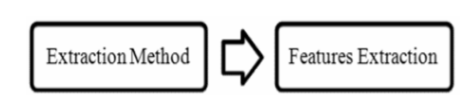

**Figure: - 3.0**

Segmentation process is the first process for recognizing Object of Interest. It is the process of dividing the input image (in this case Object of Interest image) into regions separated by boundaries.

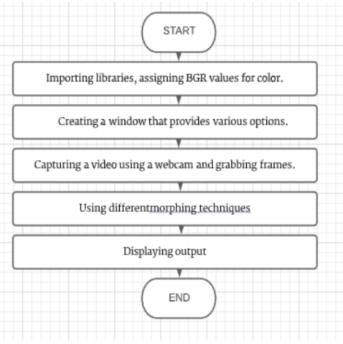

**Figure: - 3.1**

Good segmentation process leads to perfect features extraction process and the latter play an important role in a successful recognition process.

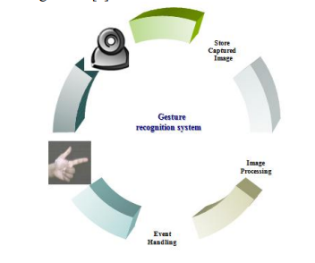

**Figure: - 4.0**

**CHAPTER 4**

**IMPLEMENATION DETAILS**

* **The Welcome Page**

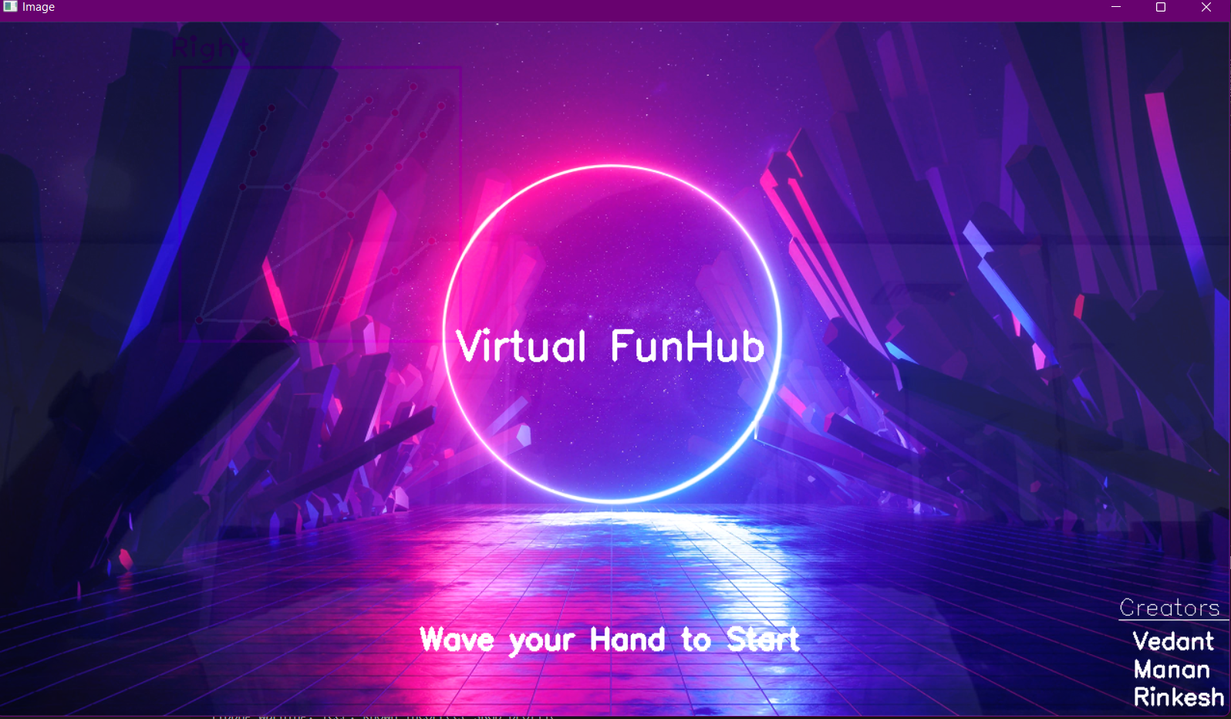

**Figure: - 5.0**

This page is the first page of the game you need to wave your hand to start the game.

After the waving we will have the loading page to load the game (Which is image displayed for a particular time)

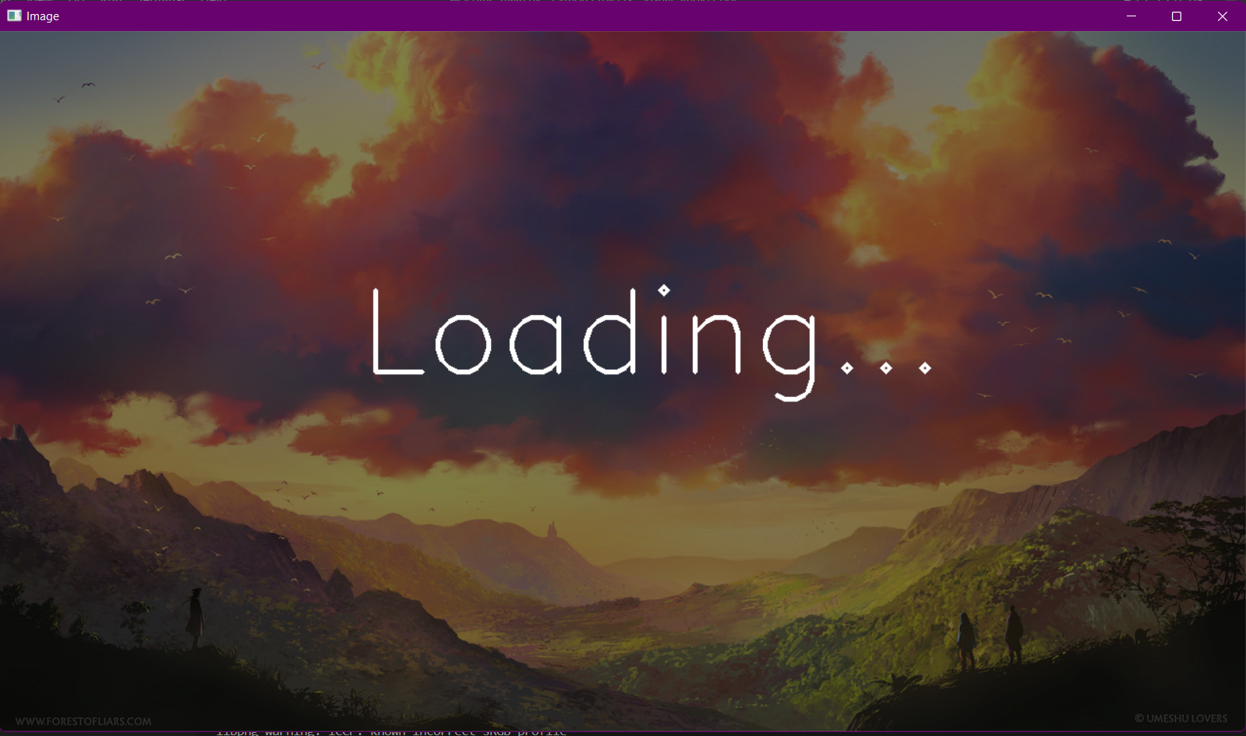

**Figure: - 5.1**

* **Main Interface for Games**

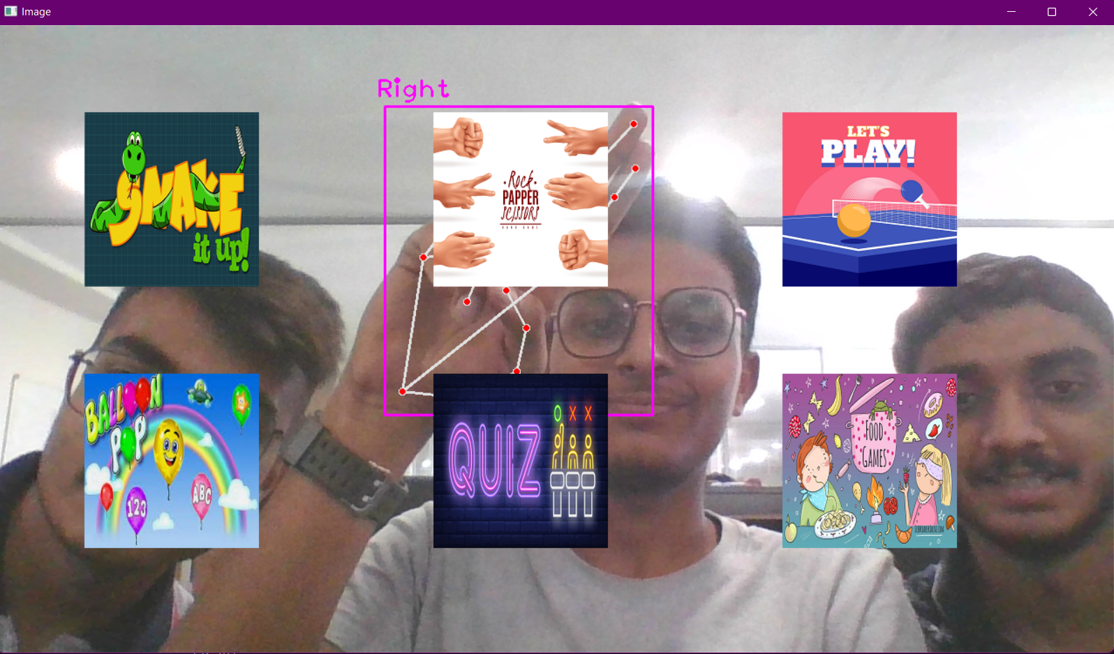

**Figure: - 6.0**

Select the game you want to play using 2 fingers. Which is the selection mode to select and play the games, after selection of the game welcome page will appear till the game is loading and the game will start.

**List of Games:**

* + **Snake Game**
  + **Rock Paper and Scissors**
  + **Eat or Not**
  + **Pong Game**
  + **Balloon Pop**
  + **Virtual Quiz**
* **Snake Game**

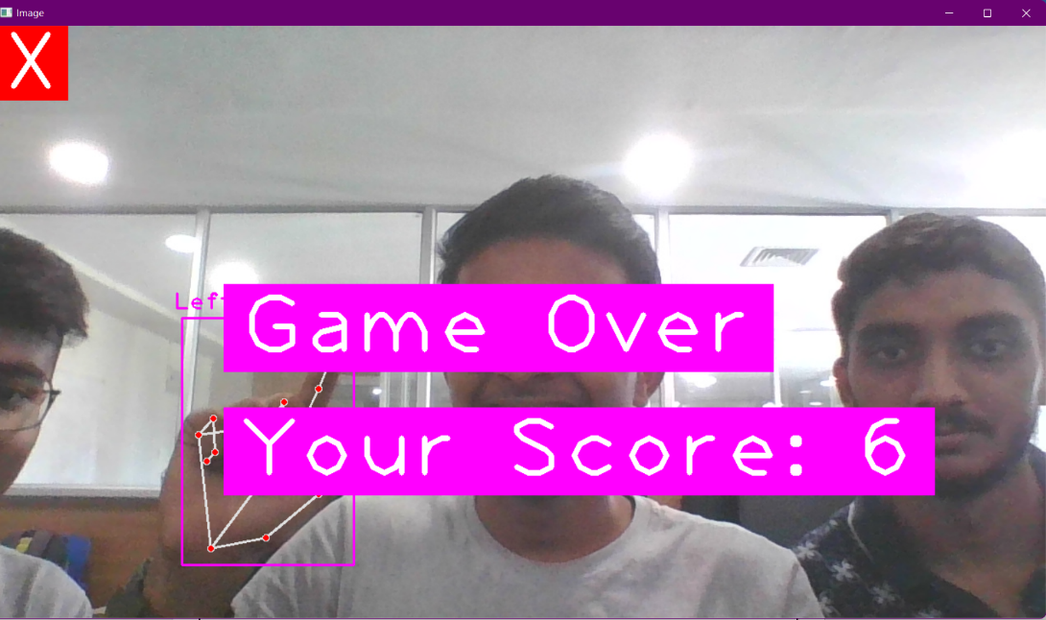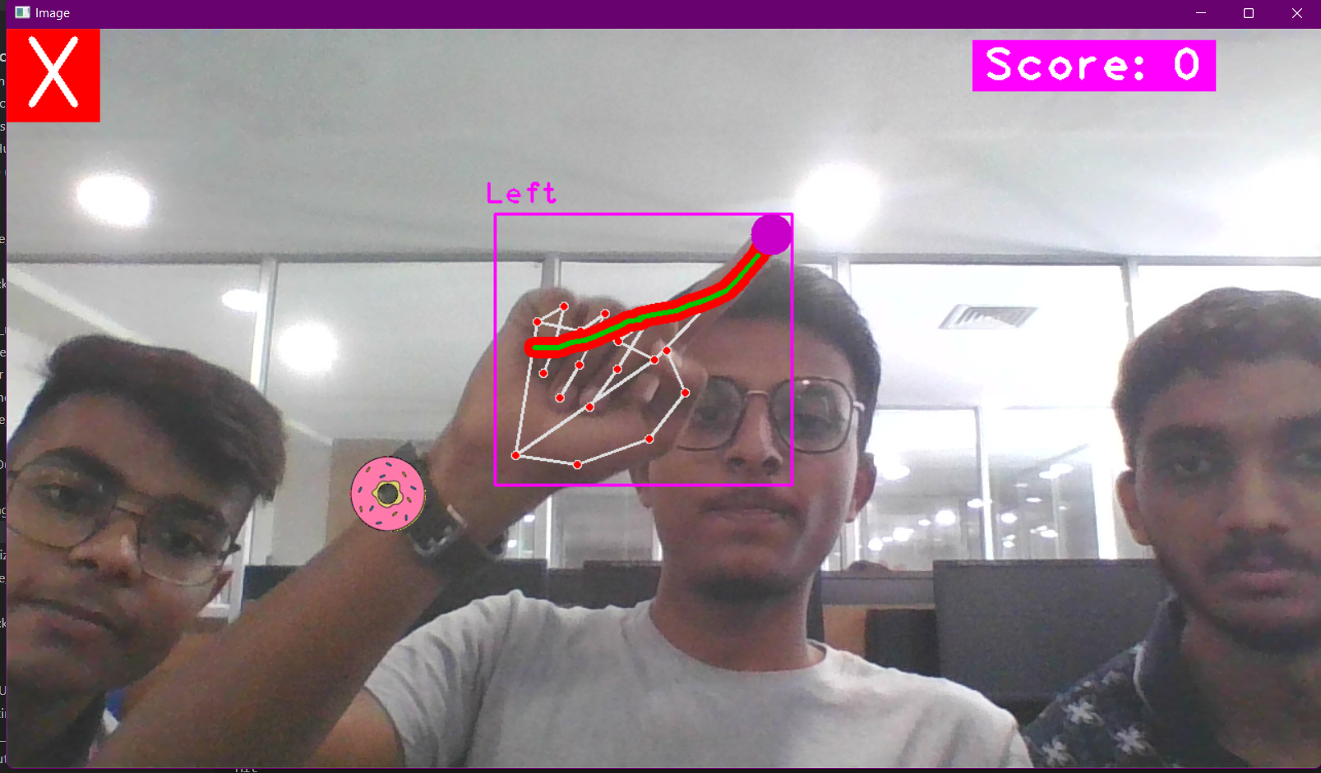

**Figure: - 7.0**

This game is old Nokia game which is one of the best games where snake grows until you eat the food and if snake touches itself or the outskirts the game is over with the score.

You can quit the game if you place your fingers onto the left top corner “**X**”

* **Rock Paper And Scissors**

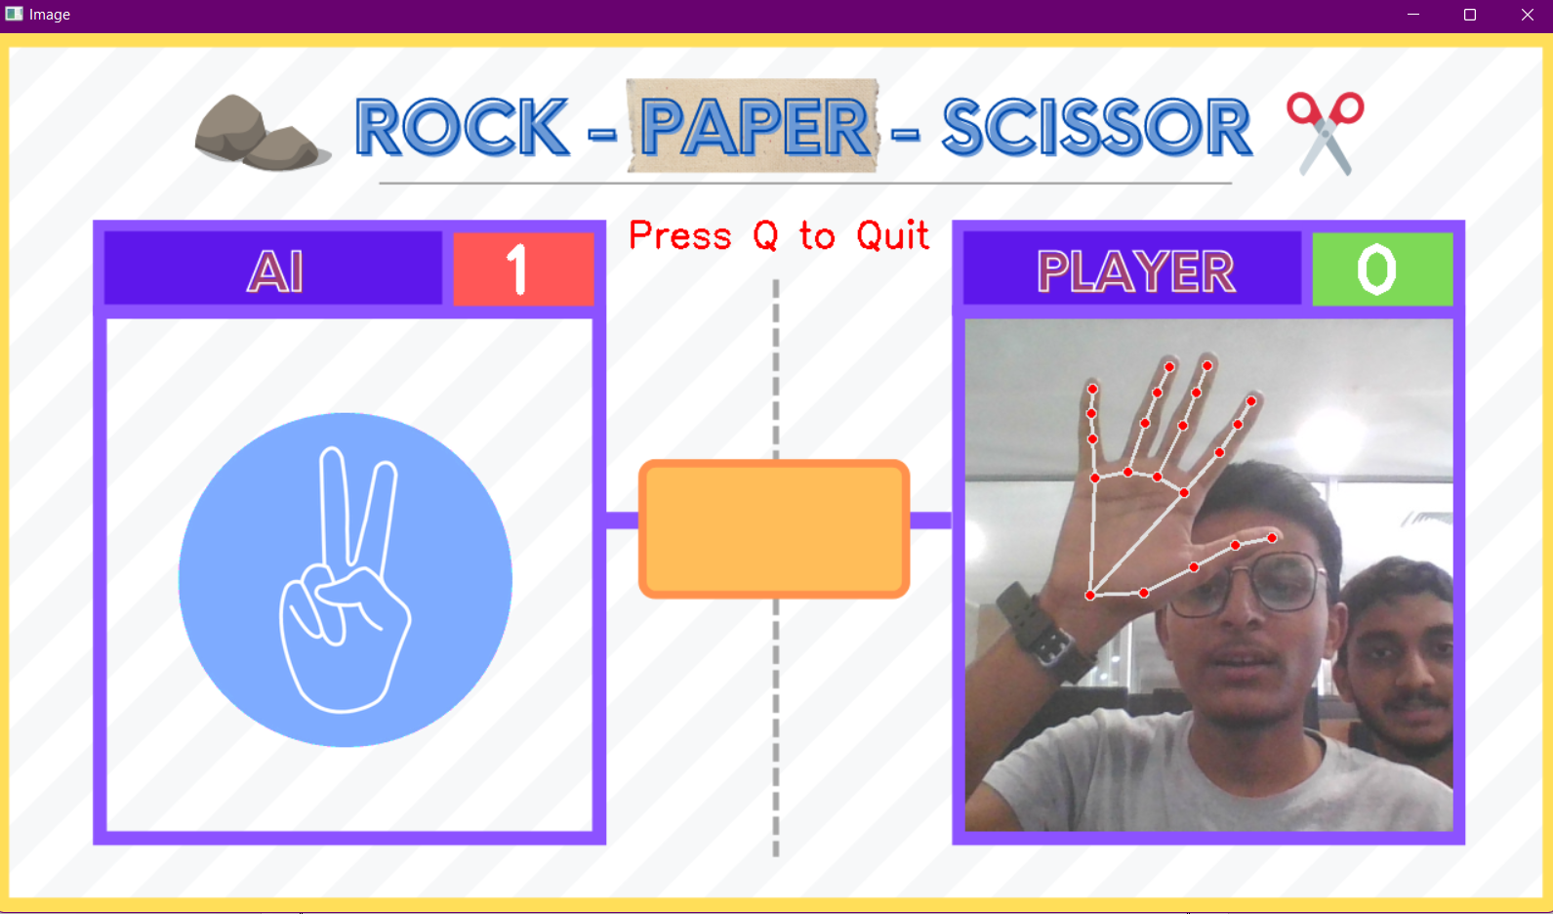

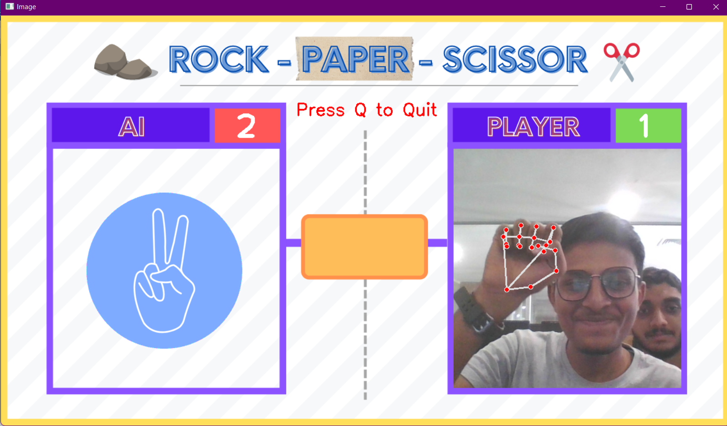

**Figure: - 8.0**

This game is the old most famous games where we will select rock, paper or scissor and we will calculate the score if the user wins then users score will increase or rather AI score will increase.

You can press “**Q”** to quit the game and get back to the interface.

* **Eat or Not**

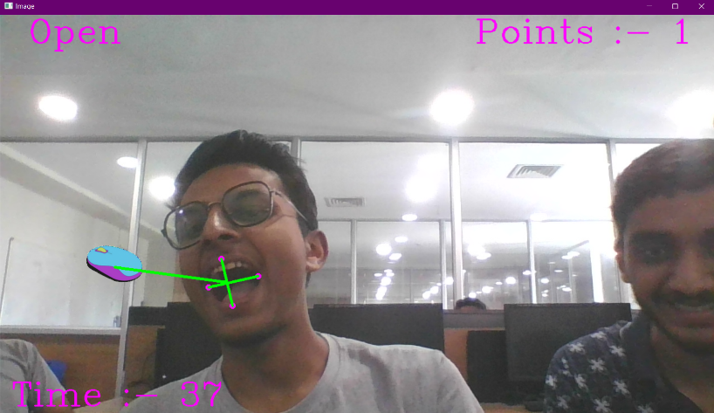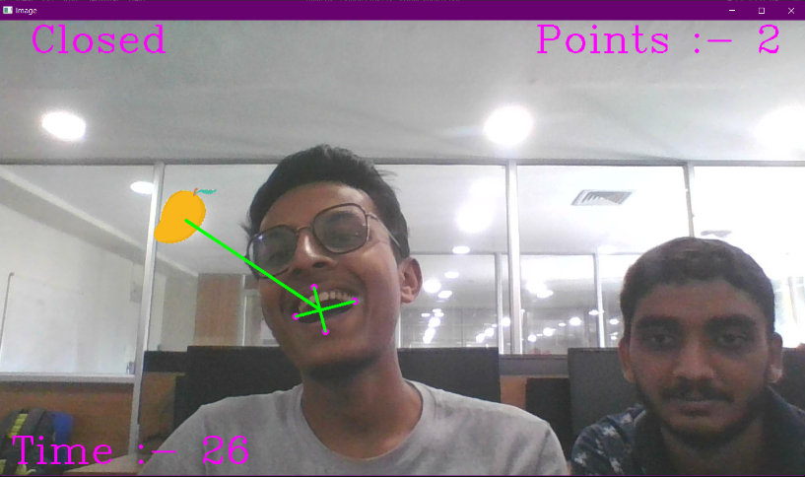

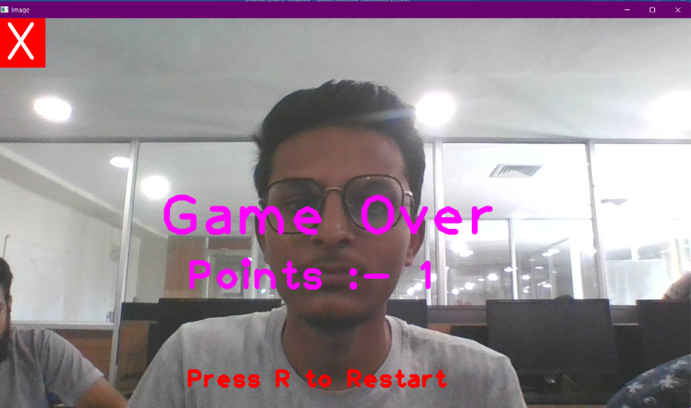

**Figure: - 9.0**

This game is used for children to show which things to eat and which to not and if you eat the fruit the score will increase, if you eat the electric appliances the game will over or the game will get over after the time is up

The score will be printed and you can restart the game by pressing “**R**” and go back to the interface by using the symbol at top left corner “**X**”

* **Pong Game**

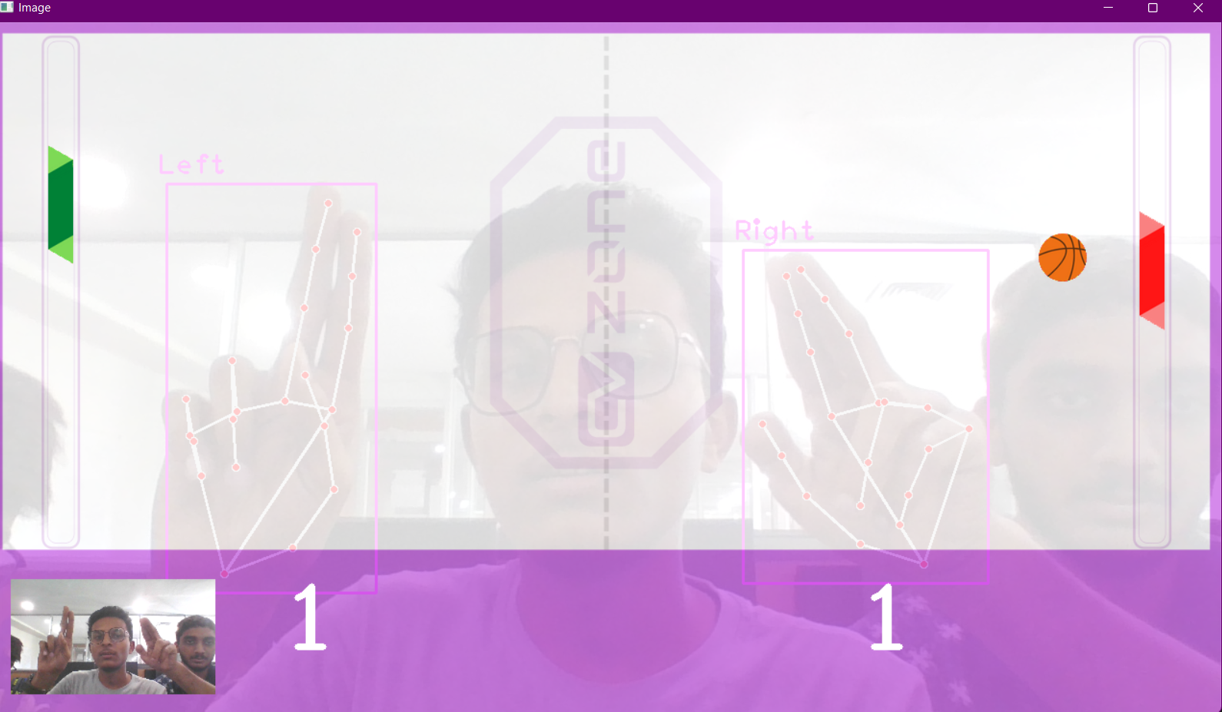

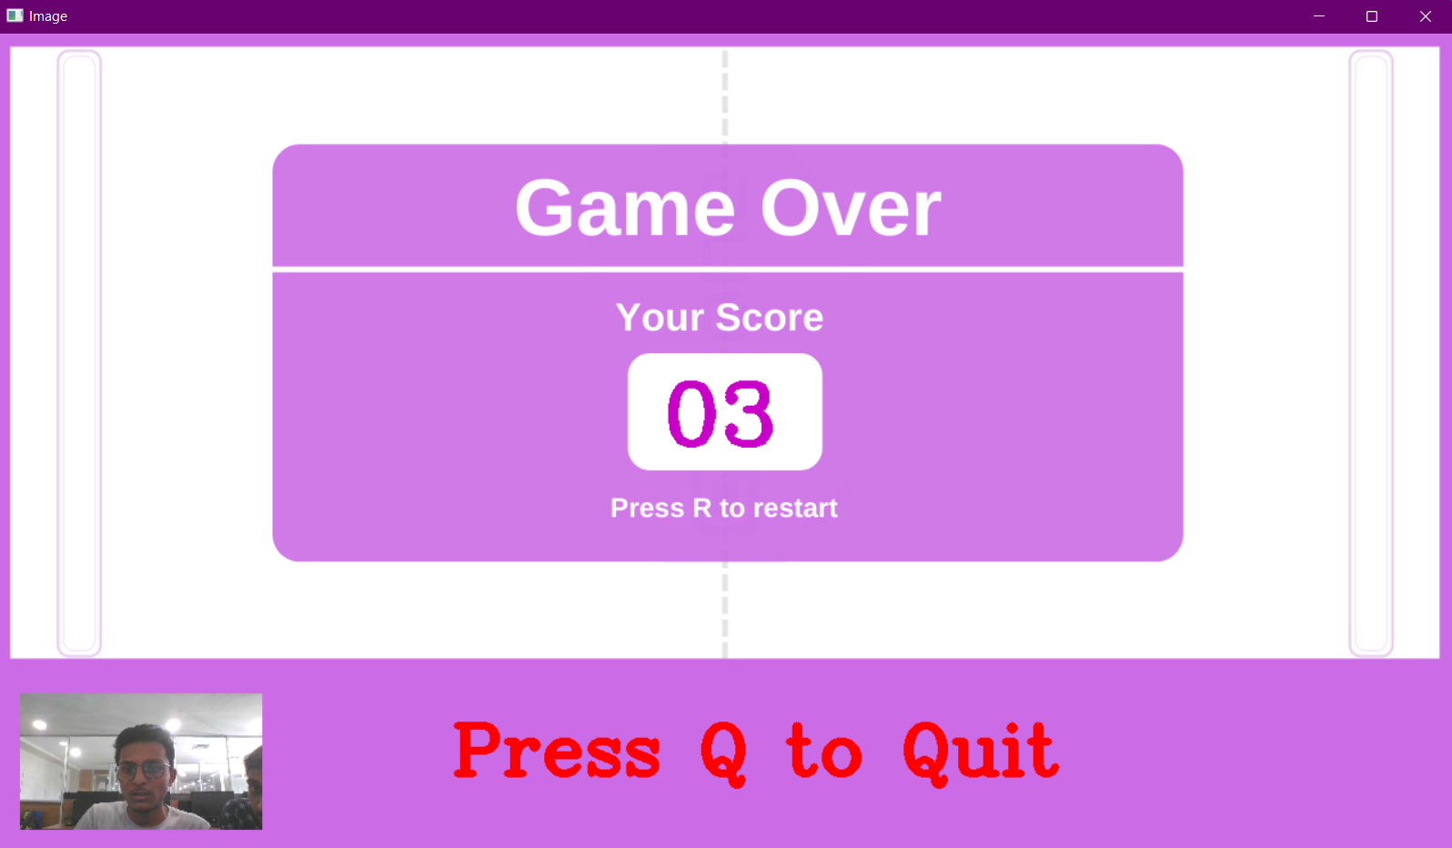

**Figure: - 10.0**

This is a multiplayer game which you can play with any of your friend you need to hit the ball until one of you misses it the game will continue and if the ball is missed the score will be displayed

You can Restart by pressing “**R**” and quit the game by pressing “**Q**”.

* **Balloon Pop**

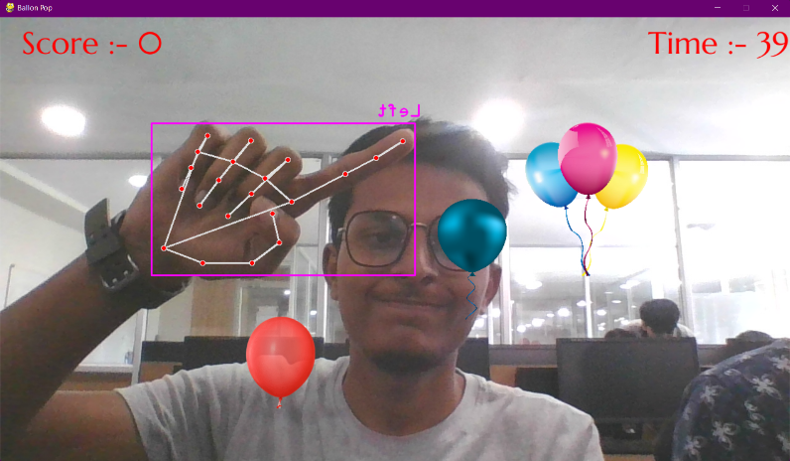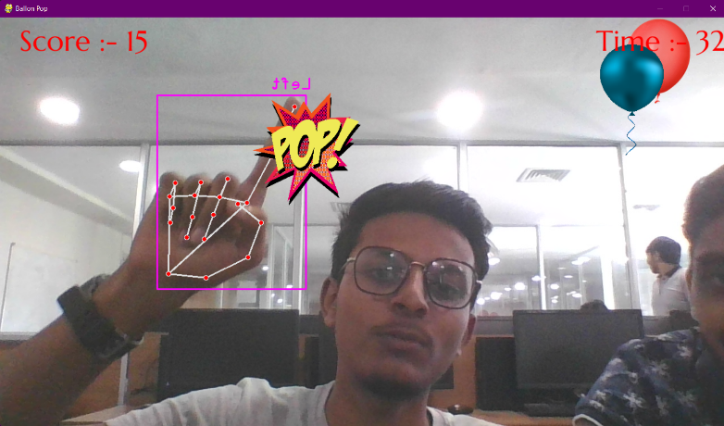

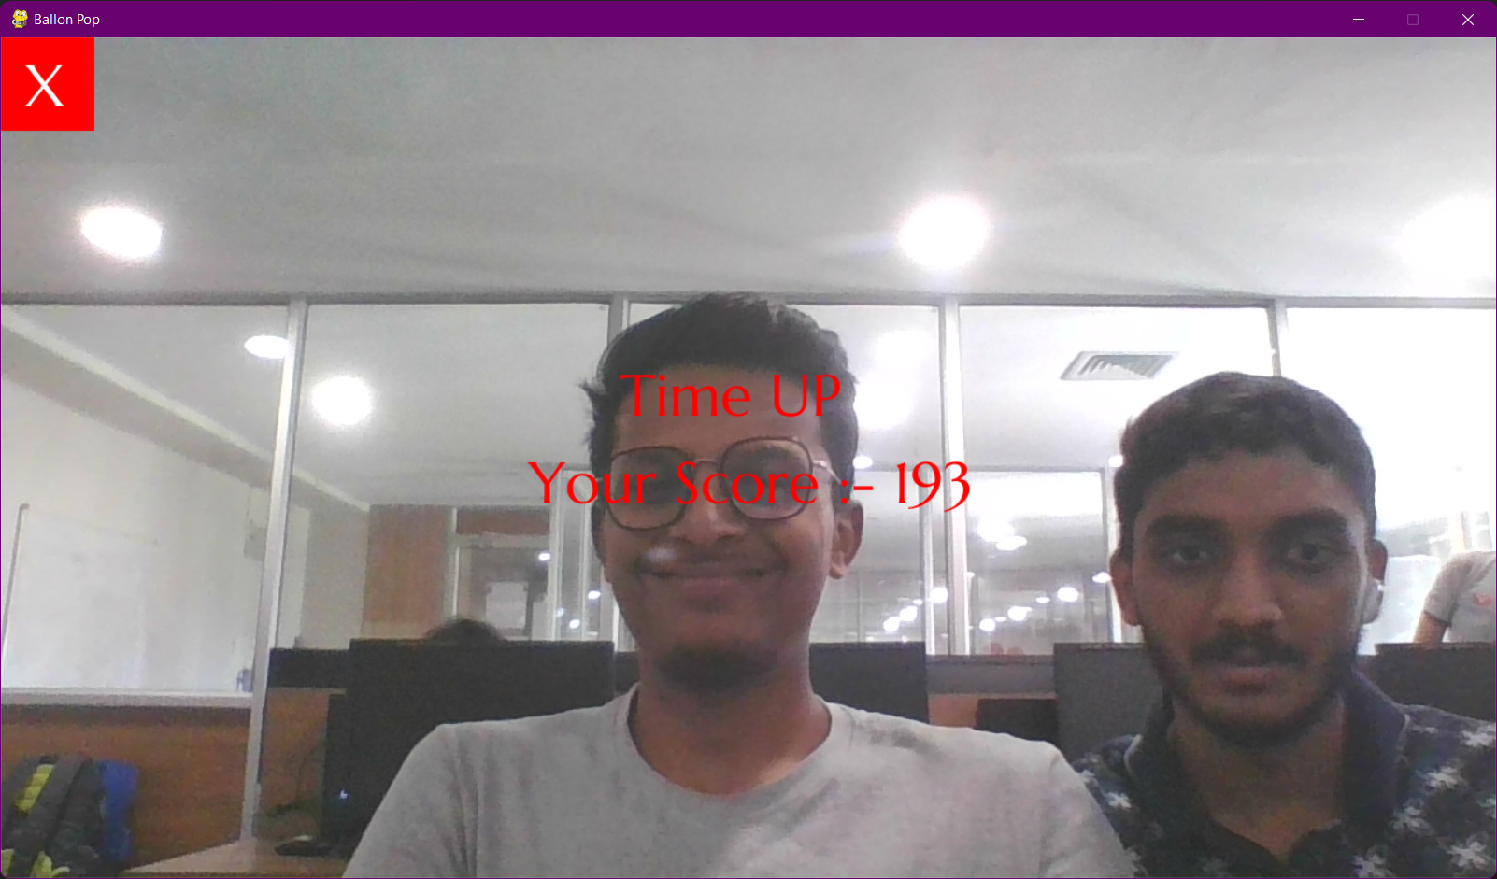

**Figure: - 11.0**

This game is for small kids in which we need to pop the balloons coming from all the directions and if you pop the balloon the “pop” image will be displayed for the fraction of seconds and after the time is over the score will be disaplayed.

You can quit the game by using the symbol at top left corner “**X**”.’

* **Virtual Quiz**

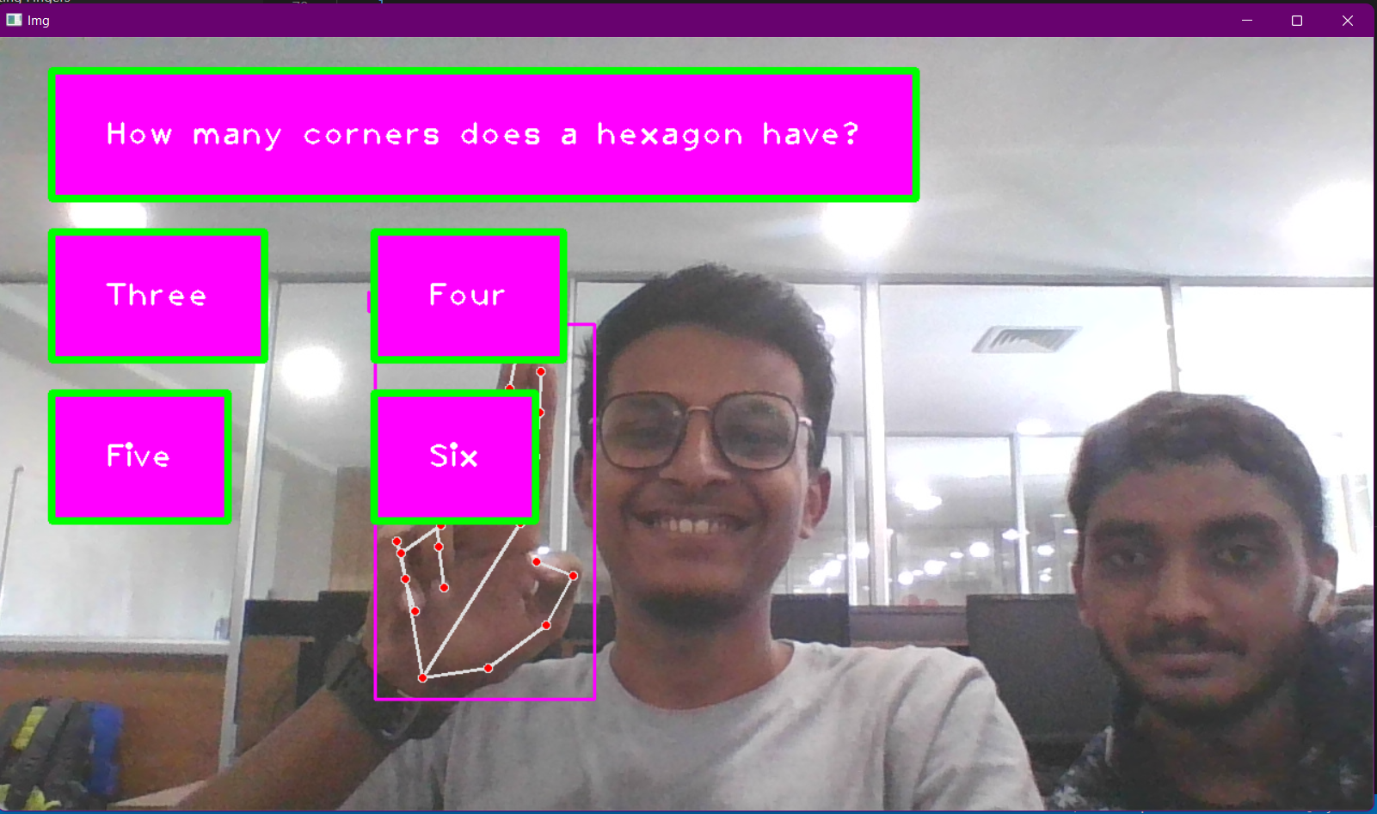

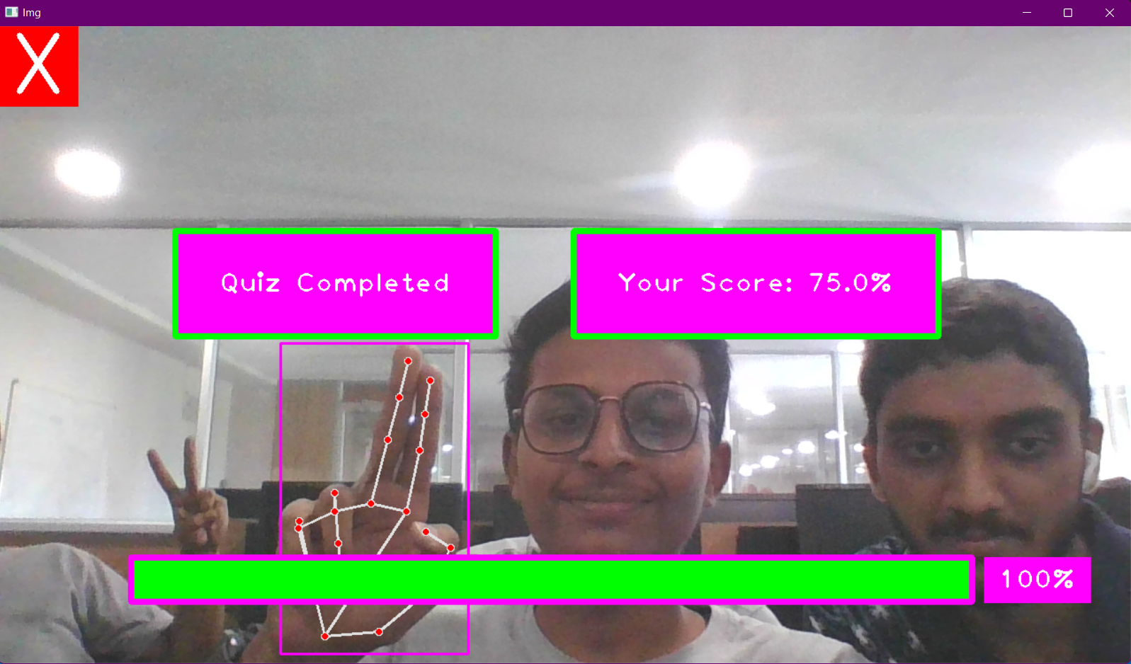

**Figure: - 12.0**

This game is a virtual quiz where you need answer the questions appearing on the screen.

The questions are appearing from the **quiz.csv** file which consist of all the questions

You can quit the game by using the symbol at top left corner “**X**”.’

* **The Loading Page**

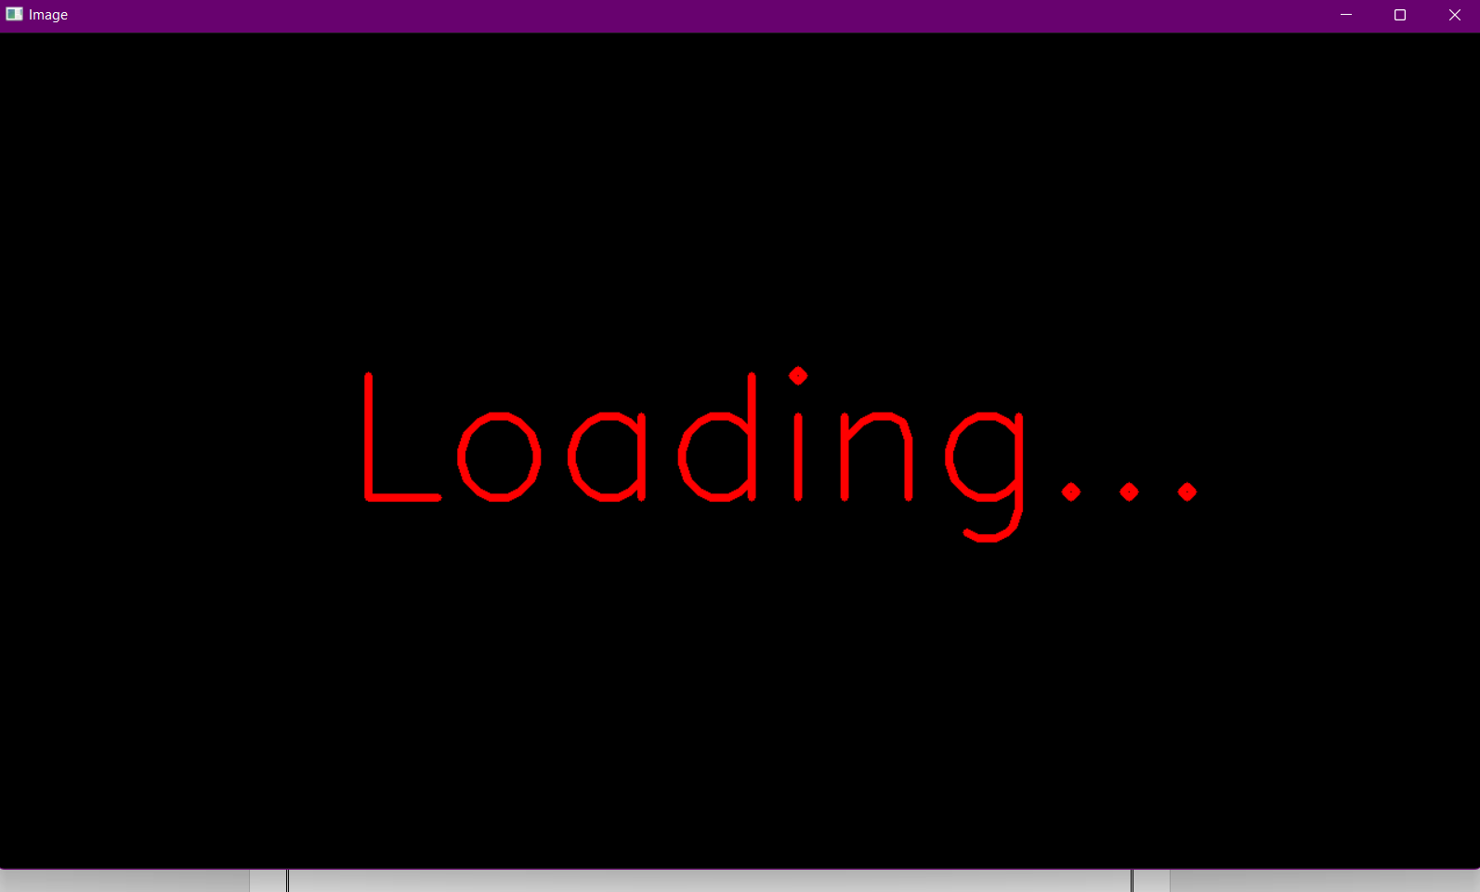

**Figure: - 13.0**

This is the loading page which will appear when the game is loading or you go back to the interface after quitting the game.

**CHAPTER 5**

**CONCLUSION AND FUTURE WORK**

**CONCLUSION**

This project makes the user to have an interactive environment where the user can select the game and play the virtual game of his desire.

So, we conclude that Virtual FunHub is developed using the library NumPy and in Open CV where we have many libraries and algorithm in built which makes the interfaces more active while using. We used python as, it have many inbuilt libraries and many modules which represent the imagination virtually when used along with OpenCV as well as its morphological processes

Demonstration of the image processing capabilities of OpenCV. The ultimate goal is to create a computer vision machine learning application that promotes Human computer interaction (HCI) also named Man Machine Interaction (MMI) refers to the relation between the human and the computer or more precisely the machine

**FUTURE WORK**

* Without any dark background hand gesture will be detected from the image.
* More sophisticated ways of Gesture recognition from various other human actions will take place instead of just hand gestures.
* Voice recognition system will be coupled with gesture recognition system which will then completely remove the requirement of hardware like Key-board and Mouse
* Video processing using Mobile devices such as smart phones, iPads and tablet pcs are equipped with cameras, the demand of the image processing applications increased.
* Controlling the robot using gestures considered as one of the interesting applications in this field proposed a system that uses the numbering to count the five fingers for controlling a robot using hand pose signs.

REFERENCES

* https://towardsdatascience.com/Virtual-Games
* <https://www.geeksforgeeks.org/live-webcamdrawing-using-opencv>
* OpenCV for Computer Vision Applications
* <https://docs.opencv.org/master/d5/d54/group__obj>
* <https://circuitdigest.com/tutorial/real-life-objectdetection-using-opencv-python-detectingobjects-in-live-video>
* http://en.m.wikipedia.org/wiki/Object_detection